Building an Efficient Data Model
Tyler Daniels
Southern New Hampshire University
CS-600
Professor Kardell
10-18-26

Building an Efficient Data Model
For the ACME Materials application, I designed a relational data model that organizes customer and product information into five entities: CUSTOMER, CUSTOMER_ADDRESS, CUSTOMER_CONTACT, PRODUCT, and INCOMING_STOCK. I separated these entities based on the information each one represents and how that information needs to change over time. This structure supports the required customer and product operations while allowing multiple addresses, contacts, and incoming deliveries without repeatedly storing the same customer or product details.
The CUSTOMER entity stores a unique customer identifier and customer name. CUSTOMER_ADDRESS and CUSTOMER_CONTACT connect to it through customer_id foreign keys. The diagram shows that a customer can have zero or many addresses and contacts, while each address or contact belongs to exactly one customer. Allowing zero related records is a design assumption that lets employees create a customer before entering all supporting information. Separate records also make it possible to update one address or remove an outdated contact without changing the customer’s other information.
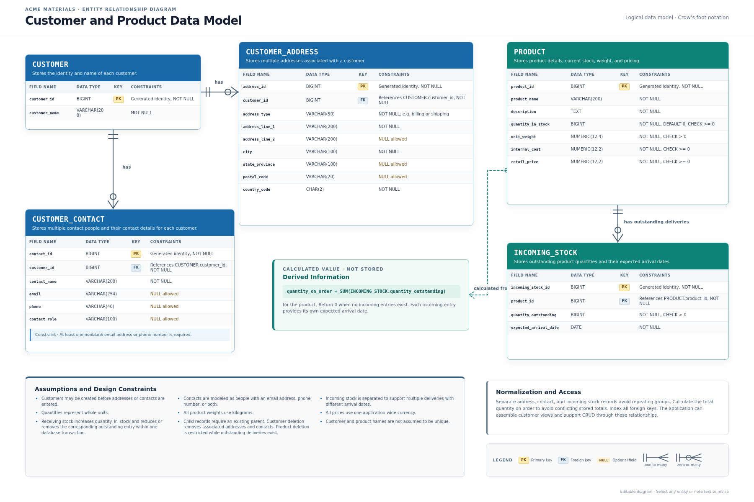
The PRODUCT entity stores the product identifier, name, description, quantity in stock, individual weight, internal cost, and retail price. I placed outstanding deliveries in INCOMING_STOCK because a product could have several deliveries arriving on different dates. Each incoming entry stores its outstanding quantity and expected arrival date. The total quantity on order is calculated by adding the outstanding quantities for that product, with a result of zero when no incoming entries exist. This meets the requirement to provide a quantity on order while avoiding a separately stored total that could become inconsistent with the delivery records.
The data types and constraints help define what valid information looks like. Generated BIGINT primary keys provide stable identifiers without requiring customer or product names to be unique. VARCHAR fields store names, addresses, and contact details, while TEXT accommodates product descriptions. Phone numbers and postal codes are stored as text because they may contain letters, symbols, or leading zeros. NUMERIC fields provide defined decimal precision for prices and weights. DATE represents expected arrival dates, and whole-number quantities reflect the assumption that products are counted as individual units.
The model also includes rules to prevent incomplete or invalid records. Stock quantities and prices cannot be negative, individual product weight must be greater than zero, and outstanding delivery quantities must be positive. A contact must have at least one nonblank email address or phone number. Some address fields are optional to accommodate differences between international address formats. The diagram assumes that weights use kilograms and prices use one application-wide currency. Making these assumptions visible helps identify decisions that stakeholders need to confirm before implementation.
Normalization is a major strength of the design. Separate address, contact, and incoming stock tables avoid repeating groups, such as address_1, address_2, and address_3 within a customer record. Additional entries can be added as rows without changing the table structure. Foreign keys preserve the relationships between records, and indexing those keys can help the application retrieve related information efficiently. The structure also gives developers a clear basis for implementing customer views and CRUD operations. However, the schema alone does not guarantee performance. Actual queries, indexes, and expected data volumes would still need testing.
Maintaining accurate inventory requires application behavior as well as database constraints. As noted in the diagram, receiving a delivery should increase the quantity in stock and reduce or remove the corresponding outstanding entry within one database transaction. This keeps the two changes together if an operation fails. The model also specifies that deleting a customer removes the associated addresses and contacts, while deleting a product is restricted when outstanding deliveries exist. These rules protect against orphaned records, although customer deletion policies would need review if ACME later introduces retention or audit requirements.
The model has limitations that reflect its current scope. It does not track suppliers, purchase order numbers, delivery history, inventory movements, or historical prices. Removing a completed incoming entry would therefore lose that delivery’s history. Supporting those capabilities would require additional entities or fields. The whole-unit quantity assumption would also need to change if ACME sells materials by weight, length, or volume. Multiple currencies or measurement units would require explicit identifiers and conversion rules rather than relying on application-wide assumptions.
The design provides a foundation for future expansion and integration. Supplier and purchase order entities could connect to incoming stock, while sales orders and order lines could connect customers with products. I did not include a direct customer-to-product relationship because the current requirements do not describe purchases. Stable identifiers and clearly defined field types would help other applications exchange records through an API, although external systems might require their own identifier mappings. Creating this model helped me see how small choices about relationships, constraints, and calculated values affect both current functionality and future development. In professional work, I would use the diagram to review assumptions with stakeholders before those choices become part of the application.

